Given a binary tree, determine if it is a *complete binary tree*.

**Definition of a complete binary tree from**[**Wikipedia**](http://en.wikipedia.org/wiki/Binary_tree#Types_of_binary_trees)**:**  
In a complete binary tree every level, except possibly the last, is completely filled, and all nodes in the last level are as far left as possible. It can have between 1 and 2h nodes inclusive at the last level h.

**Example 1:**

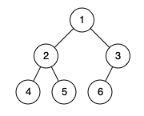

**Input:** [1,2,3,4,5,6]

**Output:** true

**Explanation:** Every level before the last is full (ie. levels with node-values {1} and {2, 3}), and all nodes in the last level ({4, 5, 6}) are as far left as possible.

**Example 2:**

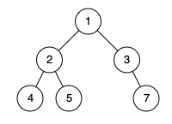

**Input:** [1,2,3,4,5,null,7]

**Output:** false

**Explanation:** The node with value 7 isn't as far left as possible.

**Note:**

1. The tree will have between 1 and 100 nodes.